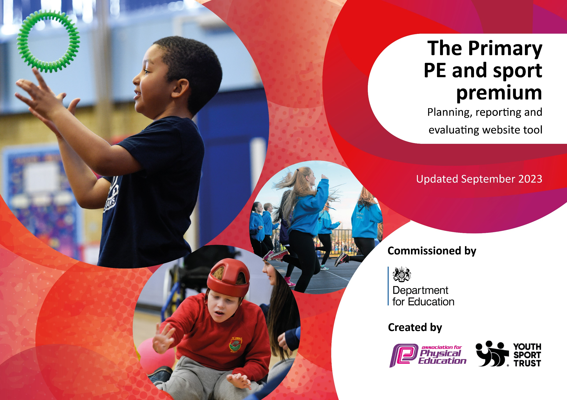

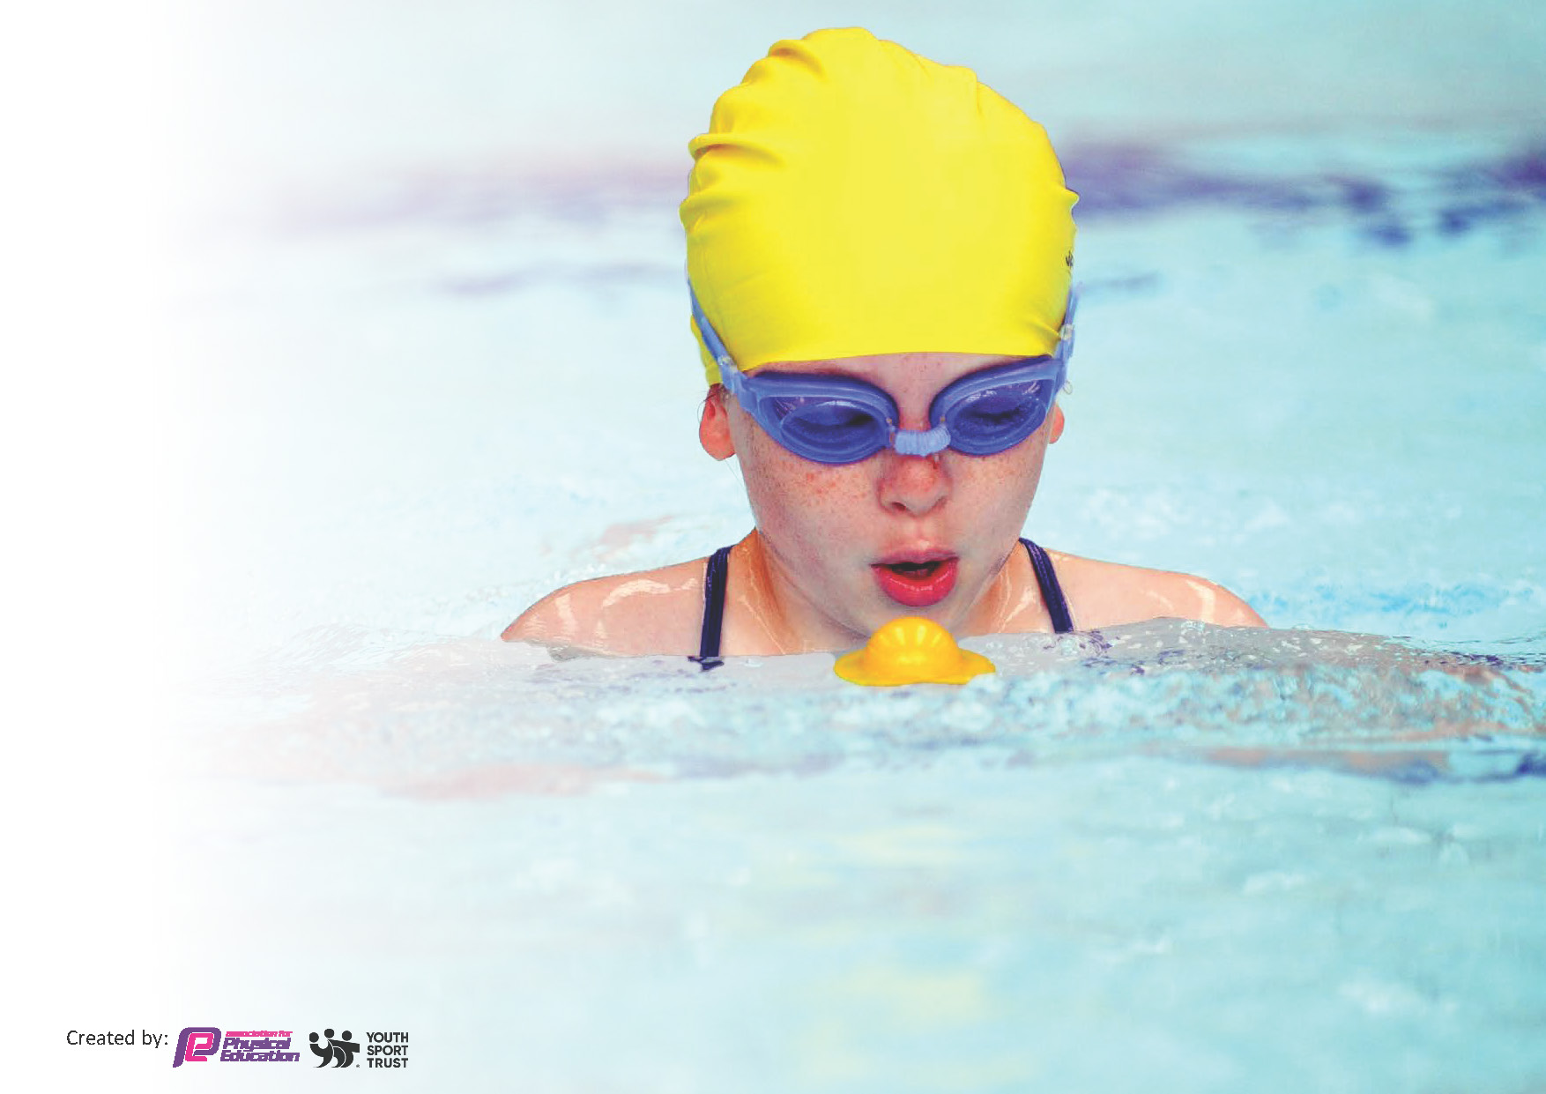
This template can be used for multiple purposes:
by:
- It enables schools to effectively plan their use of the Primary PE and sport premium
- It helps schools to meet the requirements (as set out in guidance) to publish information on their Primary PE and sport premium
- It will be an effective document to support Ofsted inspections enabling schools to evidence progress in Physical Education (PE) and evidence swimming attainment, which forms part of the PE National Curriculum. We would recommend schools consider
the Intent, Implementation and Impact of any spend, as examined within the Education Inspection Framework.

It is important that your grant is used effectively and based on school need.

Schools must use the funding to make additional and sustainable
improvements to the quality of the PE, School Sport and Physical Activity (PESSPA)
they offer. This means that you should use the Primary PE and sport premium to:

- Build capacity and capability within the school to ensure that improvements made now will benefit pupils joining the school in future years
- Develop or add to the PESSPA activities that your school already offers.

The Primary PE and sport premium should not be used to fund capital spend projects; the school’s core budget should fund these. Further detail on capital expenditure can be found in the updated Primary PE and sport premium guidance.

The Primary PE and sport premium guidance, outlines 5 key priorities that funding should be used towards. It is not

necessary that spending has to meet all the key priorities, you should select the priorities that you aim to use any funding towards.

Although completing this template is not a requirement for schools, schools are required to publish details of how they spend this funding. Schools must also outline what the impact this funding has had on pupils’ PE and sport participation and attainment and how any spending will be sustainable in the future. All funding must be spent by 31st July 2024.

The Department for Education has worked closely with the Association for Physical Education (afPE) and the Youth Sport Trust (YST) to develop this template and encourages schools to use it. This template is an effective way of meeting the reporting requirements of the Primary PE and sport premium.

Key priorities and Planning
This planning template will allow schools to accurately plan their spending.

Action – what are you planning to do | Who does this action impact? | Key indicator to meet | Impacts and how sustainability will be achieved? | Cost linked to the action
To continue to ensure children have 60 minutes of being physically active - increase physical activity levels and engagement.  To ensure active lunchtime opportunities for all children are embedded by buying into playground leader training for welfare staff and pupils.  Continue to monitor and ensure that equipment is readily available for all children at play times and lunch times to encourage daily activity.  Continue to offer opportunities for children to access after school clubs – an increase in % reported term on term from targeted offers.  Opportunities for ALL children to take part PP, SEN focus.  To continue to ensure there are specific and sufficient resources and high-quality equipment to allow children to access the curriculum at their physical competency level to develop their skills and allowing teachers to deliver effective lessons.  To provide PE CPD to all teaching staff, derived from audit to increase staff confidence and ability to lead PE and improve knowledge and understanding.  To ensure that assessment is being used effectively with the new PE App.  To ensure the curriculum mapping demonstrates coverage of a wide range of sports using the Pe App.  To continue to offer a wider range of activities both within and outside the curriculum in order to get more pupils involved in physical activity and providing them with a variety of experiences/skills and sporting opportunities.  Provide the children with the opportunity to take part in a wider range of sports clubs.  To continue to allow children to experience competition into different forms.  - inter-house competitions.  - participation in external sporting events.  - opportunities for children to apply skills learnt in lessons and clubs. | Lunchtime supervisors / teaching staff, coaches - as they need to lead the activity  pupils – as they will take part.  Pupils  Pupils  Pupils and staff  Pupils and staff  Staff  Staff  Pupils  Pupils  Pupils | Key indicator 2 -The engagement of all pupils in regular physical activity – the Chief Medical Officer guidelines recommend that all children and young people aged 5 to 18 engage in at least 60 minutes of physical activity per day, of which 30 minutes should be in school.  Key indicator 4: Broader experience of a range of sports and activities offered to all pupils.  Key indicator 4: Broader experience of a range of sports and activities offered to all pupils.  Key Indicator 1: Increased confidence, knowledge, and skills of all staff in teaching PE and sport.  Key Indicator 3: The profile of PE and sport is raised across the school as a tool for whole school improvement  Key Indicator 4: Broader experience of a range of sports and activities offered to all pupils.  Key indicator 4: Broader experience of a range of sports and activities offered to all pupils.  Key Indicator 4: Broader experience of a range of sports and activities offered to all pupils.  Key indicator 5: Increased participation in competitive sport.  Key Indicator 3: The profile of PE and sport is raised across the school as a tool for whole school improvement Key Indicator 4: Broader experience of a range of sports and activities offered to all pupils. | More pupils meeting their daily physical activity goal, more pupils encouraged to take part in PE and Sport Activities.  Extra-curricular clubs increase sporting opportunities and engagement  Competitions lead by SRBC are well organized and well attended by St Aidan’s. | £2929.02 for playtime equipment and pe lesson equipment.  Playground leader training included in £3680 for SRBC.  Club included in £3680 for SRBC.  £525 – cheerleading club.  £2929.02 for playtime equipment and pe lesson equipment (as above).  Cost included in the cheer and SRBC offer (as above.)  £1838.25  Included in the SRBC sports offer.  £575 transportation to events.

e.g. CPD for teachers. | Primary generalist teachers. | Key Indicator 1: Increased confidence, knowledge, and skills of all staff in teaching PE and sport.  Key indicator 5: Increased participation in competitive sport. | Primary teachers more confident to deliver effective PE supporting pupils to undertake extra activities inside and outside of school, including teaching water safety and swimming and as a result improved % of pupil’s attainment in PE. | £5000 for 5 teachers to undertake CPD.

Key achievements 2023-2024
This template will be completed at the end of the academic year and will showcase the key achievements schools have made with their Primary PE and sport premium spending.

Activity/Action | Impact | Comments
Attending more competitions | We attended most of the competitions provided by SRBC, offering a great number of opportunities for our children to sample competitive interschool sport. | Travel costs increased and as more competitions were attended more coaches and mini-busses were required in 2023-24 than initially anticipate
After school clubs | Each year group within school were offered at least two free ASC opportunities to partake in further sport and physical activity
Buy into SRBC sport partnership - | Dance from the Heart, whole school festival  Whole School Sports Festival, with all children from KS2 took part.  Competition entrance / organization; we attended most events that were made available | The children loved their coaches and the extracurricular opportunities  The whole school cricket festival was thoroughly enjoyed and we will be buying into more next year.
Offer each child an opportunity to experience a sporting activity that they may not have had access to before. | Children enjoyed attending sports trips to experience new activities that many had not encountered (Bowling and crown green bowling were at the top of the list)

Swimming Data
Meeting National Curriculum requirements for swimming and water safety.
Priority should always be given to ensuring that pupils can perform safe self-rescue even if they do not fully meet the first two requirements of the National Curriculum programme of study

Question | Stats: | Further context  Relative to local challenges
What percentage of your current Year 6 cohort can swim competently, confidently and proficiently over a distance of at least 25 metres? | 89% | 2 children did not meet the required 25m.
What percentage of your current Year 6 cohort can use a range of strokes effectively [for example, front crawl, backstroke, and breaststroke]? | 89% | 2 children can not use a range of strokes effectively.

What percentage of your current Year 6 cohort are able to perform safe self-rescue in different water-based situations? | 100% | Use this text box to give further context behind the percentage.
If your schools swimming data is below national expectation, you can choose to use the Primary PE and sport premium to provide additional top-up sessions for those pupils that did not meet National Curriculum  requirements after the completion of core lessons. Have you done this? | Yes/No
Have you provided CPD to improve the knowledge and confidence of staff to be able to teach swimming and water safety? | Yes/No | Priority next year will be to book 3 staff members onto CPD course.

Signed off by:

Head Teacher: | Leanne Finch
Subject Leader or the individual responsible for the Primary PE and sport premium: | Abigail Baron (year 1 teacher and PE Subject leader)
Governor: | Charlotte Barrie (PE Governor)
Date:

