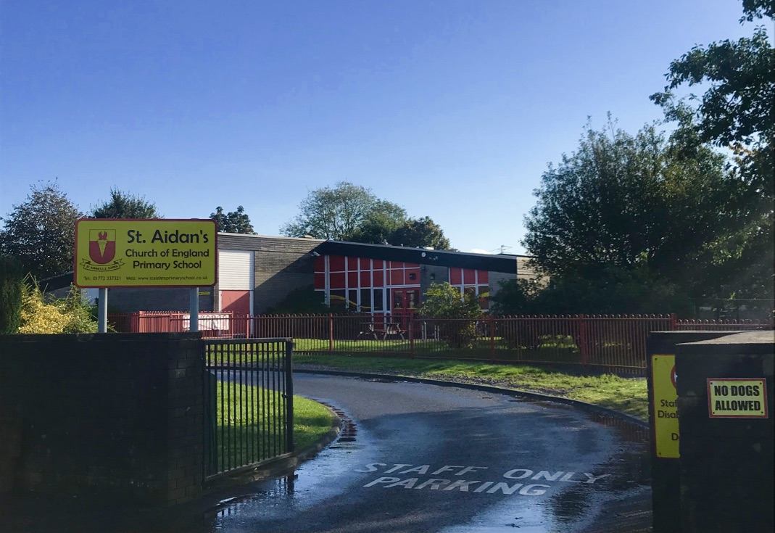

**St Aidan’s CE Primary School**

School Prospectus



**Contents:**

Headteacher’s welcome

1. School vision
2. Admissions
3. The curriculum
4. Meet the team
5. School uniform
6. Parental involvement
7. School meals
8. Welfare
9. Behaviour and attendance
10. Extra-curricular activities
11. School council
12. Special educational needs and disabilities (SEND)
13. School trips and visits
14. Community links
15. School policies
16. School closures
17. The governing board
18. School governors
19. Useful contacts

## **Headteacher’s welcome**

I am very proud to be able to share with you the wonderful opportunities and developments at St Aidan's CE Primary School!

St Aidan's is a vibrant school where children are enthusiastic and motivated to achieve endless possibilities. The children are at the heart of every decision we make to ensure that they are happy, confident and that the opportunities that are provided for them are relevant to their needs both now and in the future.

At St Aidan's, we believe that children should be curious about their learning.  Through our engaging curriculum, we ensure that children can foster a passion for learning that will help to develop high aspirations and a lifetime of memories. We believe in ensuring that children receive a well-rounded curriculum; where individual talents can be spotted and nurtured to ensure that all children experience success and reach their full potential.

The school has a dedicated team that works hard to reach high standards in everything we do and this is further embedded through our successful relationships with parents, the local community and the other schools within the Axia Learning Alliance and also the WRIST cluster. We firmly believe that education is a partnership between home and school and regard you as an active partner in your child's education and value your interest and support.

We are passionate about delivering an education to our pupils that is well rounded, informative, challenging, stimulating and, most of all, fun. We want our pupils to leave school ready for their future – whilst being able to look back with fond memories. Every child should be encouraged to reach their full potential and ready themselves for adulthood. This school enables pupils to explore education and become creative thinkers and well-rounded learners. We do this by offering a wide range of learning techniques with an exciting curriculum to match.

We are all proud of what we achieve here at St Aidan’s! We hope that you will enjoy taking the time to look through this prospectus and learn how we are going to ensure that your child gets the most out of their education.

Kind regards,

Leanne Finch

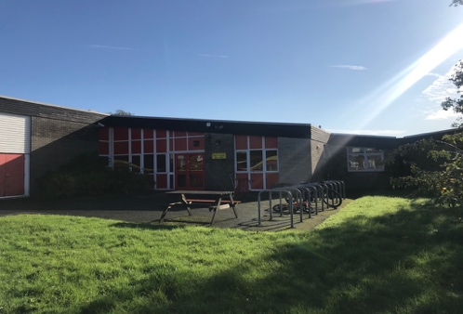 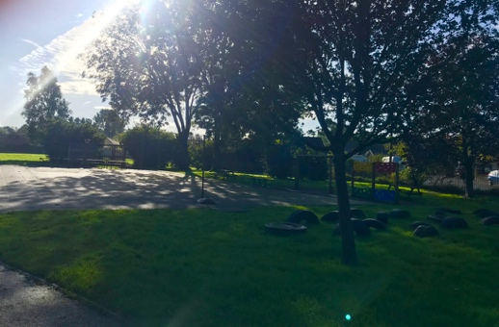

**In the light of Jesus may we live, laugh, love and learn.**

**School Motto: LIVE, LAUGH, LOVE, LEARN**

**Live every moment in the light of God, in a way that helps you to be the best that you can be.**

**Laugh every day, seek more joy and laughter in your life.**

**Love beyond words, showing care and respect.**

**Learn to grow, as Jesus taught us, to be the best you can be.**

**Our Vision**

Everyone needs to feel safe and cared for if they are to learn and succeed.  We create a warm, safe and nurturing environment that meets and matches the needs of everyone in our school community.  We understand that people encounter many ups and downs within their lives and at times may need more support than others; this includes supporting our children, parents and teachers during times of transition.  We teach our children empathy and understanding, and adults’ model this at all times.

**Our Values**

Each class in school has a class value that they work towards during the year.  Parents are invited to school each half term to watch their child's class value worship.

|  |  |
| --- | --- |
| Busy Bees | Thankfulness |
| Caterpillars | Courage |
| Butterflies | Forgiveness |
| Ladybirds | Hope |
| Grasshoppers | Truthfulness |
| Scorpions | Compassion |

# Admissions

Our school welcomes pupils from the beginning of September, following their fourth birthday. Our Admissions Policy is implemented in line with the ‘School Admissions Code’ to ensure fairness and transparency with regards to admissions. We also address, within the policy, issues of over-subscription criteria, admission appeals and pupil registration. You can request a copy of our Admissions Policy from our school office by emailing bursar@st-aidans-pri.lancs.sch.uk.

# The curriculum

For pupils to be successful in education, we have designed our lessons to:

* Be broad and balanced.
* Promote the spiritual, moral, cultural, intellectual and physical development of children.
* Prepare children for the opportunities, responsibilities and experiences of adult life.

We strongly encourage pupils to explore the curriculum and engage with learning at every opportunity – as such, we offer varying learning techniques that appeal to all types of learners.

We aim to develop pupils’ self-esteem, confidence, skills and knowledge throughout the curriculum. We respect diversity and will provide equal opportunities to all pupils, ensuring that positive relationships are encouraged, and any bullying or disrespectful behaviour is disciplined in accordance with our Behavioural Policy. We appreciate that you will want to be involved as much as possible with what your children are learning, so, as well as the brief description of the subjects below, parents will be sent a summary of their child’s syllabus for each subject at the start of the new term.

**Homework**

There is a homework policy available on request and homework is set on a half termly basis. Teachers will set homework according to the individual needs of children and of each age group. This work will cover such areas as:

* Learning spellings and multiplication tables
* Reading

We feel that it is of vital importance that children should read at home on a regular basis – DAILY IN MOST CASES - and we recommend parents spend time reading with their children in a quiet relaxed atmosphere. A home/school reading programme is in operation and further information and advice on how you can help your child is always available.

Children in their final year at school will be set more specific homework tasks as they prepare for their end of year tests and also to establish valuable learning habits for their time at High School.

# Meet the team

Sending your child to a new school can be daunting, so we would like you to be familiar with who will be looking after your children throughout the day. We are really proud of the team we have here – they have plenty of experience and, between them, they create an education environment for pupils that is stimulating, challenging and fun.

|  |  |
| --- | --- |
| Headteacher | Mrs Leanne Finch |
| Deputy Head | Mrs Hannah Bull |
| Reception/Year 1 Class Teacher | Mrs Nicola Kennedy |
| Teaching Assistant | Ms Debbie Sanderson |
| Year 2 Class Teacher | Mrs Abigail Baron |
| Teaching Assistant | Miss Clare Young |
| Year 3 Class Teacher/SENCO | Mrs Diane Gant |
| Teaching Assistant | Mrs Michelle Evason |
| Year 4 Class Teacher | Mrs Hannah Bull |
| Teaching Assistant | Miss Charlotte Barrie |
| Year 5 Class Teacher | Miss Helena Clarke |
| Teaching Assistant | Mrs Michelle Evason |
| Year 6 Class Teacher | Mrs Katie Wade |
| Teaching Assistant | Mrs Lesley Saint |
| School Business Support | Miss Elli McKenna |
| Family Support Worker | Mrs Joanne Rowley |
| Site Supervisor | Mrs Gina Worden |
| Cleaners | Mrs Lorraine Rixson |
|  |  |
|  |  |

# 

# School uniform

The following uniform is worn by the children:

* White polo shirts
* Red round neck sweatshirt or cardigan, either plain or with the school badge on.
* Grey trousers, skirt, pinafore or shorts
* Grey, black or white socks
* Red, grey, black or white tights.
* Sensible, low heeled shoes or black trainers

Sweatshirts and cardigans can be ordered through our school supplier.

  In Summer

* Red gingham or striped summer dress.
* Optional grey shorts.

Infants also require a St Aidan's book bag.  
Juniors are requested to use a St Aidan's backpack.  
Both of these items are available at the school office.

**P.E**

In the interest of health and safety, children must change for P.E and wear suitable footwear.

* Black pumps
* Trainers for outdoor games
* Black shorts
* Plain coloured t-shirt (colour dependent on house team)
* Black joggers for outdoor P.E or track suits (optional)

PLEASE NAME ALL ITEMS OF CLOTHING AND SCHOOL UNIFORM CLEARLY.

# Parental involvement

We appreciate that parents play a vital role in ensuring the success of our pupils and we want to provide every opportunity for you to get involved. We encourage you to take interest in your child’s learning as much as possible by:

* Using paired reading with your child
* Volunteering to be a chaperone on school trips
* Being a member of the PTA
* Volunteering at fundraising events

If you would like to be involved in any of the above, you can contact our Headteacher using the contact information in the useful contacts section.

We understand that you all lead busy lives and fully appreciate that you may not have the time to dedicate to all parental involvement activities. Even if this is the case, we still want you to have a say and stay informed – we will send information to you via the following methods:

* Weekly newsletters
* Letters home
* Our school Facebook page
* Our school website

These methods will be on top of your child’s annual progress report, annual parents’ evenings and any pre-arranged meetings organised throughout the academic year.

# School meals

At our school, pupils have the choice between having meals cooked and served in school or bringing in a packed lunch from home. We will, of course, cater for pupils eligible for free school meals – to be eligible for free school meals, you must be in receipt of at least one of the following:

* Income Support
* Income-based Jobseeker’s Allowance
* Income-related Employment and Support Allowance
* Support under Part VI of the Immigration and Asylum Act 1999
* The guaranteed element of Pension Credit
* Child Tax Credit (provided you’re not also entitled to Working Tax Credit and have an annual gross income of no more than £16,190)
* Working Tax Credit run-on – paid for 4 weeks after you stop qualifying for Working Tax Credit
* Universal Credit – if you apply on or after 1 April, your household income must be less than £7,400 a year (after tax and not including any benefits you get)

You may also be eligible if your child is younger than five and in full-time education.

If you have any additional queries regarding your eligibility for free school meals, you can contact our school bursar using the email in our useful contacts page.

# Welfare

# We want every pupil in our school to be healthy and happy – we do know, however, that they may not always be, and when this is the case, we will do everything in our power to help that pupil. We have several provisions in place that promote the welfare of each pupil within the school.

# Behaviour and attendance

We hold very high standards of behaviour as we believe that good behaviour has a direct impact on pupils’ learning. This is why we ask all pupils to sign a behaviour agreement upon admission to school, as well as a code of conduct, to ensure that pupils understand what is expected of them from the start. We understand that behaviour issues may arise, and where this is the case, we will deal with each instance in accordance with our Behavioural Policy and ensure each pupil is treated fairly and equally.

We, of course, want to celebrate all good behaviour, and we have a rewards scheme in place for those pupils who go above and beyond to exhibit good behaviour and an outstanding commitment to their work and school life.

# Extra-curricular activities

# We believe that a safe, social atmosphere helps pupils of all ages to develop their social skills and confidence. That is why we host a number of different extra-curricular activities for pupils that occur before, after and during the school day. Find a full list of the extra-curricular activities we host on our school website, as well as information on who they are available for and when they run.

# School council

Pupil voice is extremely important to us and we value the opinions of our pupils. As part of our appreciation, the school has set up a school council. The council is set up of two members from each year group. The children are responsible for reporting back to staff the needs and wishes of our pupils in a termly meeting. We hold elections in October, where interested pupils can run for election.

# Special educational needs and disabilities (SEND)

At our school, we welcome all pupils and we pride ourselves on creating an inclusive atmosphere. We have provisions in place to ensure our pupils with SEND don’t miss out on any opportunity.

Mrs Gant, our year 3 teacher, is the school SENCO.

# School trips and visits

Each year, the school arranges numerous school trips and visits for our pupils – they are designed to enhance your child’s learning experience as well as teach them essential skills for their adult life. Take a look at the class pages on our website to see the different trips that have taken place throughout the school year.

# School policies

Part of our statutory responsibility as a school is to implement policies to ensure we run our school to the highest standards. We want to ensure that you feel happy sending your child to school every day. As a school, we are dedicated to creating a comfortable, challenging and fun learning environment for your children and our policies are one of many ways we ensure this. Below you can find a brief description of what we aim to achieve with each policy and how it will benefit our pupils, parents and staff. All of these policies can be found on the school website.

**Charging and remissions**

We are committed to ensuring equal opportunities for all pupils, regardless of financial circumstances, and have established the following policy and procedures to ensure that no child is discriminated against by our offering of school trips, activities and educational extras.

In addition, we are committed to adhering to legal requirements regarding charging for school activities, and meeting all statutory guidance provided by the Department for Education (DfE).

**We promise:**

* Not to charge for education provided during school hours.
* To inform parents on low incomes and in receipt of relevant benefits of the support available to them when asking for contributions.

**SEND**

We promiseto meet our duty and obligation to provide a high-quality education to all of our pupils, including pupils with SEND, and to do everything we can to meet the needs of pupils with SEND.

Through successful implementation of this policy, the school aims to:

* Eliminate discrimination.
* Promote equal opportunities.
* Foster good relationships between pupils with SEND and pupils without SEND.

**Admissions**

We welcome all pupils, irrespective of faiths, cultures, races, disabilities or family backgrounds.

Pupils are admitted to school in-line with the Equality Act 2010, School Admissions Code 2014, the School Admission Appeals Code 2012, Human Rights Act 1998 and the School Standards and Framework Act 1998.

The purpose of this policy is to ensure that all school places are allocated and offered in an open and fair way. The number of places available is determined by the capacity of the school and is called the ‘published admissions number’ (PAN). Our PAN is 168.

**Behaviour**

We believe that, to facilitate teaching and learning, acceptable behaviour must be demonstrated in all aspects of school life. As part of this policy and the school’s ethos, we are committed to:

* Promoting desired behaviour.
* Promoting self-esteem, self-discipline, proper regard for authority, and positive relationships based on mutual respect.
* Ensuring equality and fair treatment for all.
* Praising and rewarding good behaviour.
* Challenging and disciplining bad behaviour.
* Providing a safe environment, free from disruption, violence, discrimination, bullying and any form of harassment.
* Encouraging positive relationships with parents/carers.
* Developing positive relationships with our pupils to enable early intervention.
* Developing a shared approach which involves pupils in the implementation of the school’s policy and associated procedures.
* Promoting a culture of praise and encouragement in which all pupils can achieve.

**Relationships and sex education**

We understand the importance of educating pupils about sex and relationships, in order for pupils to make responsible and well-informed decisions in their lives.

The programme will be taught objectively and does not intend to promote any form of sexual orientation.

The sex education and relationship programme is an opportunity for pupils to:

* Develop an understanding of sex, sexuality and relationships.
* Develop a range of appropriate personal skills.

The aims will be achieved through developing an understanding of:

* A range of values and moral issues including the importance of family life.
* The biological facts related to human growth and development, including reproduction.
* The importance of healthy relationships.

**Equal opportunities**

We hope that, by establishing a clear framework to govern the treatment of all pupils at our school, we can remove human prejudice from the decision-making process and overcome any inequality, ensuring that every pupil that attends our school receives an education which offers them the best chance at fulfilling their potential.

**Equality objectives**

We recognise that, historically, certain groups have been disadvantaged on account of unlawful discrimination against protected characteristics, e.g. their sex, race, disability. As part of our statutory duty, we have published our equality objectives on our school website to eliminate prejudice, unlawful discrimination and victimisation within the school community and workforce.

**Health and safety**

We are committed to the health and safety of our staff, pupils and visitors. Ensuring the safety of our community is of paramount importance and this policy reflects our dedication to creating a safe learning environment.

We are committed to:

* Providing a productive and safe learning environment.
* Preventing accidents and any work-related illnesses.
* Compliance with all statutory requirements.
* Minimising risks via assessment and policy.
* Providing safe working equipment and ensuring safe working methods.
* Including all staff and representatives in health and safety decisions.
* Monitoring and reviewing our policies to ensure effectiveness.
* Setting high targets and objectives to develop the school’s culture of continuous improvement.
* Ensuring adequate welfare facilities are available throughout our school.
* Ensuring adequate resources are available to address health and safety issues, so far as is reasonably practicable.

**Attendance**

We believe that, in order to facilitate teaching and learning, good attendance is essential. Pupils cannot achieve their full potential if they do not regularly attend school.

We are committed to:

* Promoting and modelling good attendance.
* Ensuring equality and fairness of treatment for all.
* Intervening early and working with other agencies to ensure the health and safety of our pupils.
* Following the framework set in section 7 of the Education Act 1996 which states that:

“The parent of every child of compulsory school age shall cause him/her to receive efficient full-time education suitable:

(a) to age, ability and aptitude and

(b) to any special educational needs he/she may have

Either by regular attendance at school or otherwise”.

**Child protection and safeguarding**

We are committed to safeguarding and promoting the welfare, both physical and emotional, of every pupil both inside and outside of the school premises. We implement a whole-school preventative approach to managing safeguarding concerns, ensuring that the wellbeing of pupils is at the forefront of all action taken.

This policy sets out a clear and consistent framework for delivering this promise, in line with safeguarding legislation and statutory guidance.

Our school Designated Safeguarding Officers are:

Mrs Leanne Finch

Mrs Joanne Rowley

Mrs Hannah Bull

**Complaints procedures**

We created this policy to deal with any complaint against a member of staff or the school as a whole, relating to any aspects of the school or the provision of facilities or services.

Any person, including a member of the public, is able to make a complaint about the provision of facilities or services that the school provides. This policy outlines the procedure that the complainant and school must follow.

**Early years**

We greatly value the importance of the early years foundation stage (EYFS) in providing a secure foundation for future learning and development.

Through this policy, we want to ensure that children learn and develop well and are kept healthy and safe. We will promote teaching and learning to ensure pupils’ ‘school readiness’ and give children a broad range of knowledge and skills that provide the right foundation for good future progress through school and life.

**Data protection**

We are required to keep and process certain information about our staff members and pupils in accordance with our legal obligations under the GDPR and Data Protection Act 2018. This policy is in place to ensure all staff and governors are aware of their responsibilities and outlines how the school complies with the following core principles of the GDPR.

Organisational methods for keeping data secure are imperative, and we believe that it is good practice to keep clear practical policies, backed up by written procedures.

# 

# The governing board

The role of the governing board is to ensure that our school provides an effective education for our children and meets all the statutory requirements. This is a huge task, and our governors are committed and hard working. Our governing board is made up of representatives from the council, the local community, parents and staff. The governing board meets every term and discusses issues relating to the management of the school, such as the budget, premises, safeguarding and health and safety.

If you are interested in becoming a governor, please contact our headteacher, Mrs Leanne Finch on head@st-aidans-pri.lancs.sch.uk– please expect three working days for a response.

# School governors

We are exceptionally grateful to have such a wonderful collection of individuals working together to make our school the best it can be. A successful school is only as successful as their governing board – and we think ours is marvellous!

|  |  |
| --- | --- |
| Chair of Governors | Miss J Snape |
| Vice Chair of Governors | Mr G Baron |
| Headteacher | Mrs L Finch |
| Foundation Governors | Mrs J Snape |
|  | Mrs E Bowman |
| Parent Governors | Miss C Barrie |
|  | Mrs K Southworth |
|  | Mr D Evemy |
| Staff Governor | Mrs A Baron |
| LA Governor | Vacancy |
| Co-Opted Governors | Mr G Baron |
|  | Mrs M Evason |
|  |  |
| Observer | Mrs H Bull |

# 

# Useful contacts

|  |  |  |  |
| --- | --- | --- | --- |
| **Name** | **Job title** | **Email** | **Contact number** |
| **L Finch** | **Headteacher** | [**head@st-aidans-pri.lancs.sch.uk**](mailto:head@st-aidans-pri.lancs.sch.uk) | **01772 337321** |
| **H Bull** | **Deputy Head** | [**h.bull@st-aidans-pri.lancs.sch.uk**](mailto:h.bull@st-aidans-pri.lancs.sch.uk) | **01772 337321** |
| **E McKenna** | **Bursar** | [**bursar@st-aidans-pri.lancs.sch.uk**](mailto:bursar@st-aidans-pri.lancs.sch.uk) | **01772 337321** |
| **D Gant** | **SENCO** | **d.gant@st-aidans-pri.lancs.sch.uk** | **01772 337321** |
| **J Rowley** | **Pupil and Family Support Worker** | **j.rowley@st-aidans-pri.lancs.sch.uk** | **01772 337321** |
|  |  |  |  |
|  |  |  |  |