Governor Pen Portrait

Name:  Elizabeth Bowman | 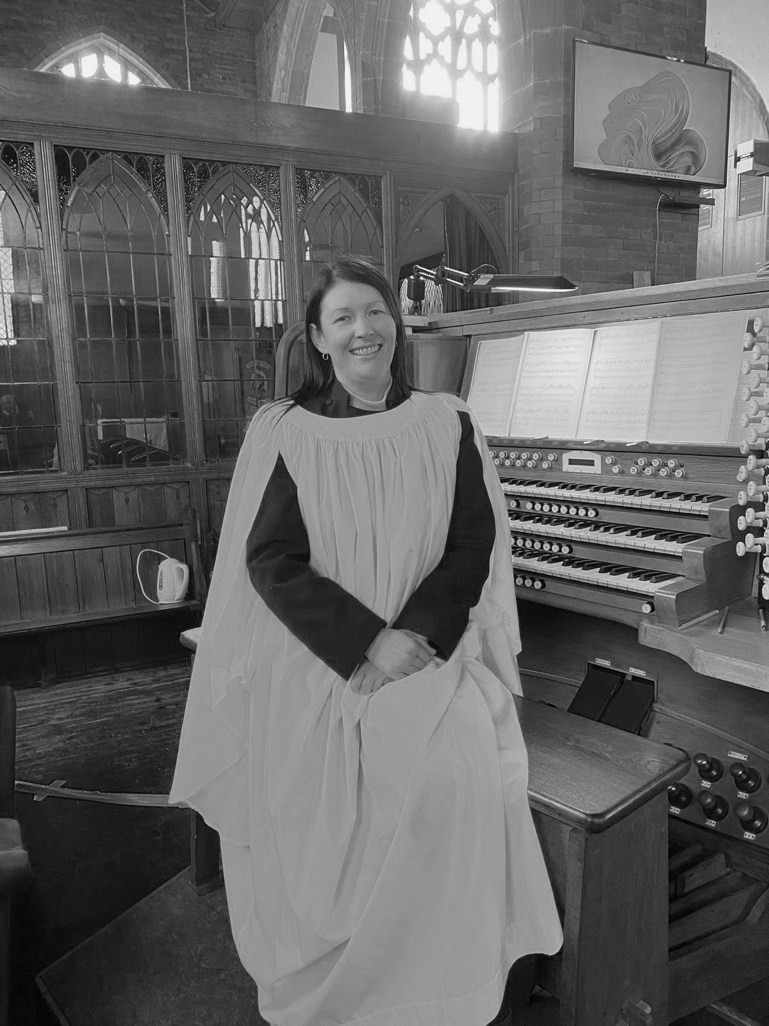
Role on the Governing Body:
Foundation Governor

Committee’s:
School Effectiveness Committee
Finance

Professional experience/current job role:
My current role is that of Head of Administration and Office Manager for a large Civil Engineering company. I have over 25 years work experience bringing a broad range of experience encompassing aspects of learning and development, HR, administration and facilities management as well as working alongside board directors.

Please explain what your knowledge and experience bring to the role of Governor at St Aidan’s:
Along with the experience gained in my professional employment I am active member of the Christian Faith and currently organist at St. Aidan’s Church. I aim to support the school to the best of my ability to ensure the children of St. Aidan’s flourish.

